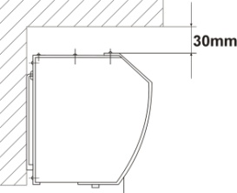
- During installation, the mounting plate should not have a gap between the walls.
- The distance between the unit and the ceiling must reserve at least 30mm.
- The unit is installed horizontally.
- Recommend installing the machine at the height
of at least 2.3M above the ground.
- A triple pole switch should precede the appliance with at least 3mm breaking gap.

Maintenance and repair:
- Unplug the unit from any power source prior checking or maintenance.
- Keep electric motor or other parts away from moisture to avoid short circuit.
- Regular checking and maintenance is recommended, clean all the dust off. Simply damp with mild detergent by a cloth for cleaning.
- Detach the unit only by professionals.

Specification:（380V 50/60HZ）

Body length | Power  (W) |  | Air velocity  (m/s) |  | Air volume  (m³/h) | Noise  (dB) | Weight  (kg)
 | HI | LO | HI | LO
900 mm | 6000 | 4500 | 8.0 | 7.5 | 1500 | 55 | 14.5
1200 mm | 7200 | 5500 |  |  | 2500 | 57 | 18.0
1500 mm | 9000 | 7500 |  |  | 3000 | 60 | 22.0

NOTE: Rated voltage and frequency are stated as per rating label.

SIGA _ _ _ E

Cross-flow type

Instruction Manual

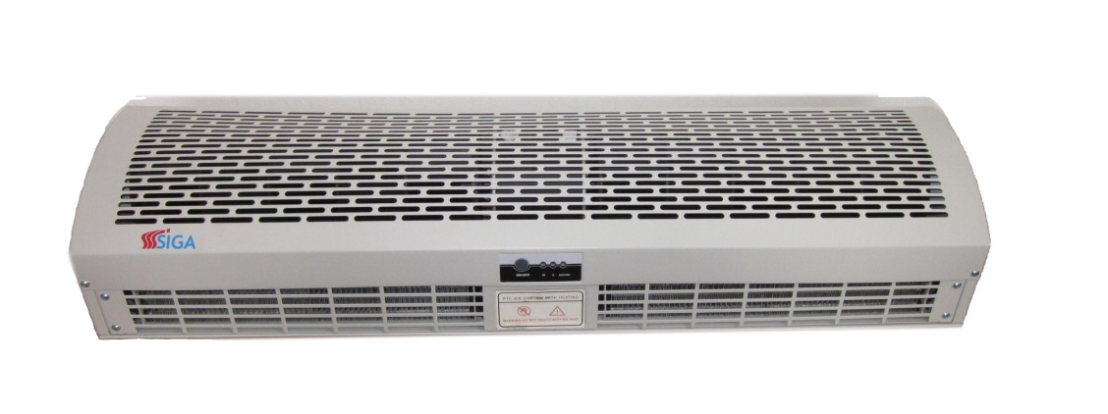

Before using this unit,
please read this instruction manual completely.

Product outline:

Air curtains are designed for installation in shops, office buildings, hotels and restaurants doorway. They discharge a curtain of air, which effectively shut out outside air. Use them to keep out insects, unpleasant smells, and dust from indoor where a large number of people pass in and out. These air curtains also prevent air escaping from an air-conditioned room.

Conditions of use:

Please DO NOT install the unit under following conditions:

- Do not operate ambient temperature over 50°C or below -10°C.
- A relative humidity over 95% at room temperature and steamy area.
- Contains of oily smoke.
- Materials or gases may cause explosion.
- Nearly corrosive gases.
- Locate in where may be sprinkle with water.

Diagram:
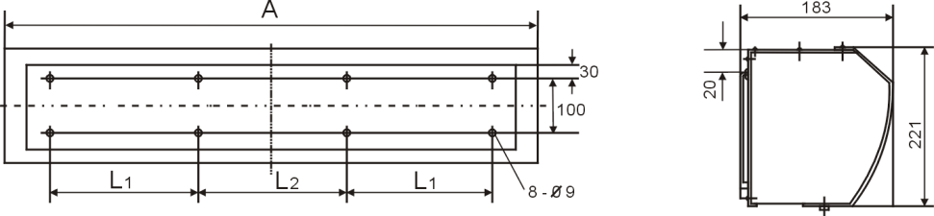
[ Dimension : mm ]

Body length | A | L1 | L2
900 | 900 | 260 | 220
1200 | 1200 | 260 | 220
1500 | 1500 | 260 | 220

Installation:

- Unscrew the mounting plate and take it off (Fig.1、Fig.2).
- Drill a hole as the instruction. Then put into the bolt and fix it with cement (Fig.3)
- Hanging on the mounting plate and ensure fix it (Fig.4).
- Installing the machine onto the mounting plate and ensure the safety, than fix it tighten with screws (Fig.5).
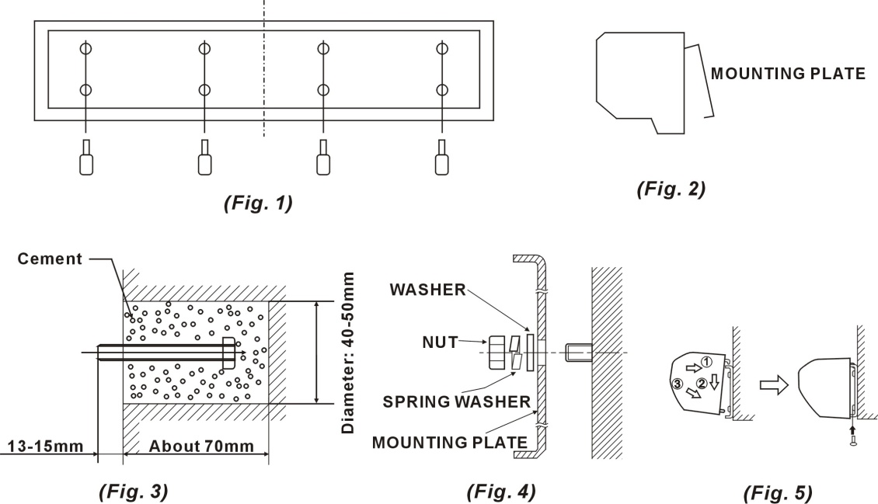

Cautions / Installations:

During installing the unit, please pay special attention to the following points in order to obtain the ultimate efficiency.

- Install on solid place to avoid vibrations when machine is running and also for safety reason unnecessary noise caused by vibration can be prevented.
- Air curtains are used for indoor purpose.
- Depending on the height to choose the most suitable model. If it fixed too high, the shut-off distance will be affected then the efficiency will be reduced.
- The air is drawn in front of the unit and is blown out downwards.
- Several units can be mounted next to each other when wide door opening occur. Under such condition, a narrow space in between 20-40mm may happened.

